**TRAINING IN PYTHON 3 LANGUAGE**

**SIX WEEK PROJECT report**

**SUBMITTED IN PARTIAL FULFILLMENT OF THE REQUIREMENT FOR THE**

**AWARD OF THE DIPLOMA (CSE)**

**Submitted by:**

**ROHAN KUMAR**

**ROLL NO - 551**

**cse 5th**



**mEHR cHAND pOLYTECHNIC coLLEGE,**

**jalandhar**

**ACKNOWLEDGEMENT**

The satisfaction that accompanies the successful completion of any task would be incomplete without the mention of people whose ceaseless cooperation made it possible, whose constant guidance and encouragement crown all efforts with success.

I would like to take this opportunity to express my gratitude towards all the people who have in various ways, helped in the successful completion of my project. Many books are the result of a collection from various sources, such as internet, newspapers, magazines etc. Unfortunately, sources were not always noted or accurate acknowledgement.

Regardless, I am grateful to my friend, for his guidance, inspiration & constructive suggestions that helped me in the preparation & execution of this project.

**Table of Contents**

|  |  |  |  |
| --- | --- | --- | --- |
| Serial No. | Contents | | Page No. |
| 1. | | Company Profile | 1 |
| 2. | | Weather Forecast Application | 3 |
| 3. | | Role of Candidate in project | 4 |
| 4. | | Technology used in Project | 5 |
| 5. | | Python Objects | 8 |
| 6. | | Python Operators | 10 |
| 7. | | Data Structures | 12 |
| 8. | | Tkinter Widgets | 15 |
| 9. | | Installation of Python | 17 |
| 10. | | System Requirement | 24 |
| 11. | | Project Technicalities | 25 |
| 12. | | Conclusion and Future Scope | 35 |

1. **COMPANY PROFILE**

O7SERVICES has the expertise to provide information Technology and Communication based Solutions. We design, develop and deploy Systems, Networking, Security and Communication Solutions. We constantly stay ahead in the Technologies and provide to our Customers solutions for sustainable competitive advent.



**Mission:**

O7services mission is to provide to Customers with a complete Solution to all their current and future Information Technology needs.

O7SERVICES has established a reputation for quality work and plans to continue to enhance its image in the Information Technology Industry.

The Company seeks to become a well-known and respected provider of Information Technology Solutions by

* Increasing service offerings.
* Increasing availability and accessibility to current and future Customers.
* Creating innovative, unique, and cost effective solutions to problems currently faced by Customers.

**Services:**

O7SERVICES combines best of breed products and technologies with global market industry knowledge and expertise and successfully addresses its Customers strategic business challenges and..opportunities.   
 With a strong base of dedicated employees, our team works closely with Customers to better understand their challenges and provide cost-saving solutions. The most important part of our Business Process is SUPPORT. O7SERVICES strongly realizes the need to be fully and readily equipped to support all their Customers who believe in them and trust them to serve and provide the right solution to their IT needs. We provide following services:-

**I.T Infrastructure**

* Network
* Storage
* System
* Security
* Backup

**2. WEATHER FORECAST APPLICATION**

This projectis designed from a user point of view. The project provides platforms for user to see current and updated weather. The login system works well for storing lists of cities the user wants to add. We can store all the information as a list. User can perform all types of operations like view, insert, update and delete operations.

Main functions of this project are:

* Manages the weather data
* Stores the cities of user’s.
* Add/manage all the list of cities
* It needs active internet connection

**3. ROLE OF CANDIDATE IN PROJECT**

The project is developing using the Python 3. Front end used in the project is also Python 3

The whole designing of the project is done by me in which Python 3 and SQL are used. Database used is MySQL and Apache as Server.

Work done by me.

**Look and feel of the Project**: **Tkinter (Module in Python 3)**

**Backend and logic of the Project: Python 3**

**Database management system: MySQL**

**4. TECHNOLOGY USED IN PROJECT**

**Programming Languages and Development Tools: -**

Python is a widely used high-level programming language for general-purpose programming, created by Guido van Rossum and first released in 1991. Python features a dynamic type system and automatic memory management and supports multiple programming paradigms, including object-oriented, imperative, functional programming, and procedural styles. It has a large and comprehensive standard library.

**Two major versions of Python are currently in active use:**

* Python 3.x is the current version and is under active development.
* Python 2.x is the legacy version and will receive only security updates until 2020. No new features will be implemented. Note that many projects still use Python 2, although migrating to Python 3 is getting easier

**Why to Learn Python?**

* Python is a high-level, interpreted, interactive and object-oriented scripting language.
* Python is designed to be highly readable.
* It uses English keywords frequently where as other languages use punctuation, and it has fewer syntactical constructions than other languages.
* Python is a MUST for students and working professionals to become a great Software Engineer especially when they are working in Web Development Domain.

**Key advantages of learning Python:**

* Python is Interpreted − Python is processed at runtime by the interpreter. We do not need to compile your program before executing it. This is similar to PERL and PHP.
* Python is Interactive − we can actually sit at a Python prompt and interact with the interpreter directly to write your programs.
* Python is Object-Oriented − Python supports Object-Oriented style or technique of programming that encapsulates code within objects.
* Python is a Beginner's Language − Python is a great language for the beginner-level programmers and supports the development of a wide range of applications from simple text processing to www browser games

**Characteristics of Python**

* It supports functional and structured programming methods as well as OOP.
* It can be used as a scripting language or can be compiled to byte-code for building large applications.
* It provides very high-level dynamic data types and supports dynamic type checking.
* It supports automatic garbage collection.
* It can be easily integrated with C, C++, COM, ActiveX, CORBA, and Java.

**Features of Python**

* Easy-to-learn − Python has few keywords, simple structure, and a clearly defined syntax. This allows the student to pick up the language quickly
* .Easy-to-read − Python code is more clearly defined and visible to the eyes.
* Easy-to-maintain − Python's source code is fairly easy-to-maintain.
* A broad standard library − Python's bulk of the library is very portable and cross platform compatible on UNIX, Windows, and Macintosh.
* Interactive Mode − Python has support for an interactive mode which allows interactive testing and debugging of snippets of code
* Portable − Python can run on a wide variety of hardware platforms and has the same interface on all platforms.
* Extendable – We can add low-level modules to the Python interpreter. These modules enable programmers to add to or customize their tools to be more efficient.
* Databases − Python provides interfaces to all major commercial databases
* GUI Programming − Python supports GUI applications that can be created and ported to many system calls, libraries and windows systems, such as Windows MFC, Macintosh, and the X Window system of Unix.
* Scalable − Python provides a better structure and support for large programs than shell scripting.

**5. PYTHON OBJECTS**

**Numbers**-Here are some direct commands to perform mathematical calculations on numbers. Python supports many types of numbers as integers (int), floating point numbers (float), complex numbers etc.

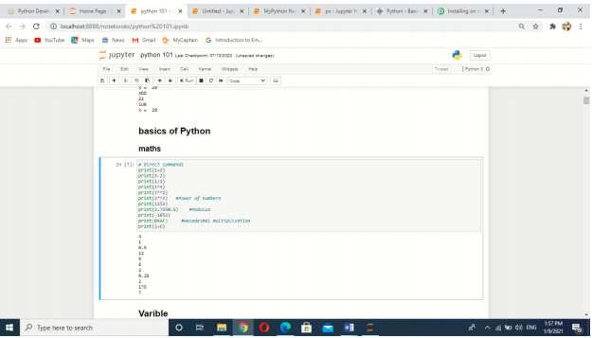

**Variables**- Variables are nothing but reserved memory locations to store values. This means that when you create a variable you reserve some space in memory. Based on the data type of a variable, the interpreter allocates memory and decides what can be stored in the reserved memory. Therefore, by assigning different data types to variables, you can store integers, decimals or characters in these variables. The declaration happens automatically when you assign a value to a variable. The equal sign (=) is used to assign values to variables. The operand to the left of the = operator is the name of the variable and the operand to the right of the = operator is the value stored in the variable. Strings are special case for assignment be case assignment of string is kept under quotes.

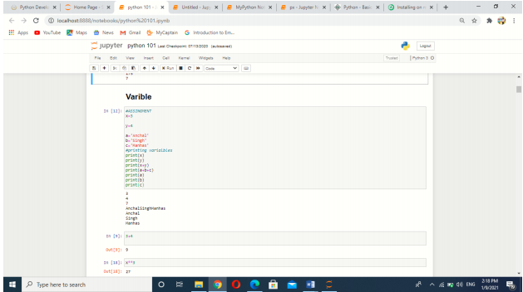

**String:** - Python string is the collection of the characters surrounded by single quotes, double quotes, or triple quotes. The computer does not understand the characters; internally, it stores manipulated character as the combination of the 0's and 1's. In Python, strings can be created by enclosing the character or the sequence of characters in the quotes. Python allows us to use single quotes, double quotes, or triple quotes to create the string.

**6. THE PYTHON OPERATORS**

Operator can be defined as a symbol which is responsible for a particular operation between two operands. Operators are the pillars of a program on which the logic is built in a specific programming language. Python provides a variety of operators, which are described as follows.

o Arithmetic operators

o Comparison operators

o Assignment Operators

o Logical Operators

o Bitwise Operators

o Membership Operators

o Identity Operators

**Arithmetic Operators: -** Arithmetic operators are used to perform arithmetic operations between two operands. It includes + (addition), - (subtraction), *(multiplication), /(divide), %(reminder), //(floor division), and exponent (**) operators.

**Comparison operator: -** Comparison operators are used to comparing the value of the two operands and returns Boolean true or false accordingly. The comparison operators are described in the following table.

**Assignment Operators: -** The assignment operators are used to assign the value of the right expression to the left operand.

**Bitwise Operators: -** The bitwise operators perform bit by bit operation on the values of the two operands. Consider the following example.

**Logical Operators:** - The logical operators are used primarily in the expression evaluation to make a decision. Python supports the following logical operators.

**Identity Operators:** - The identity operators are used to decide whether an element certain class or type

**Membership Operators: -** Python membership operators are used to check the membership of value inside a Python data structure. If the value is present in the data structure, then the resulting value is true otherwise it returns false.

**7. THE DATA STRUCTURES**

**List-**A list in Python is used to store the sequence of various types of data. Python lists are mutable type its mean we can modify its element after it created. However, Python consists of six data-types that are capable to store the sequences, but the most common and reliable type is the list.

A list can be defined as a collection of values or items of different types. The items in the list are separated with the comma (,) and enclosed with the square brackets [].

A list can be define as below

L1 = ["John", 102, "USA"]

L2 = [1, 2, 3, 4, 5, 6]

**Characteristics of Lists**

**The list has the following characteristics**:

o The lists are ordered.

o The element of the list can access by index.

o The lists are the mutable type.

o The lists are mutable types.

o A list can store the number of various elements.

**Tuple**

Python Tuple is used to store the sequence of immutable Python objects. The tuple is similar to lists since the value of the items stored in the list can be changed, whereas the tuple is immutable, and the value of the items stored in the tuple cannot be changed.

**Creating a tuple**

A tuple can be written as the collection of comma-separated (,) values enclosed with the small () brackets. The parentheses are optional but it is good practice to use. A tuple can be defined as follows.

T1 = (101, "Peter", 22)

T2 = ("Apple", "Banana", "Orange")

T3 = 10,20,30,40,50

**Set**

A Python set is the collection of the unordered items. Each element in the set must be unique, immutable, and the sets remove the duplicate elements. Sets are mutable which means we can modify it after its creation.

Unlike other collections in Python, there is no index attached to the elements of the set, i.e., we cannot directly access any element of the set by the index. However, we can print them all together, or we can get the list of elements by looping through the set.

**Creating a set**

The set can be created by enclosing the comma-separated immutable items with the curly braces {}. Python also provides the set() method, which can be used to create the set by the passed sequence

**Dictionary**

Python Dictionary is used to store the data in a key-value pair format. The dictionary is the data type in Python, which can simulate the real-life data arrangement where some specific value exists for some particular key. It is the mutable data-structure. The dictionary is defined into element Keys and values.

o Keys must be a single element

o Value can be any type such as list, tuple, integer, etc.

In other words, we can say that a dictionary is the collection of key-value pairs where the value can be any Python object. In contrast, the keys are the immutable Python object, i.e., Numbers, string, or tuple.

Creating the dictionary

The dictionary can be created by using multiple key-value pairs enclosed with the curly brackets {}, and each key is separated from its value by the colon (:).The syntax to define the dictionary is given below.

**Syntax**:

Dict = {"Name": "Tom", "Age": 22}

**Tkinter**

Tkinter tutorial provides basic and advanced concepts of Python Tkinter. Our Tkinter tutorial is designed for beginners and professionals. Python provides the standard library Tkinter for creating the graphical user interface for desktop based applications. Developing desktop based applications with python Tkinter is not a complex task. An empty Tkinter top-level window can be created by using the following steps. Import the Tkinter module. Create the main application window. Add the widgets like labels, buttons, frames, etc. to the window. Call the main event loop so that the actions can take place on the user's computer screen.

**Example**

from tkinter import *

Top = Tk()

top.mainloop()

**8. TKINTER WIDGETS**

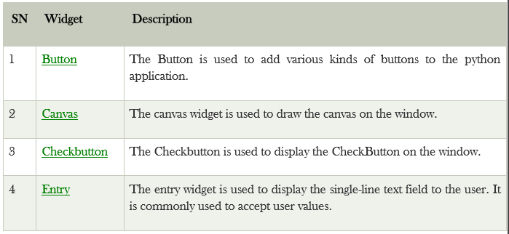

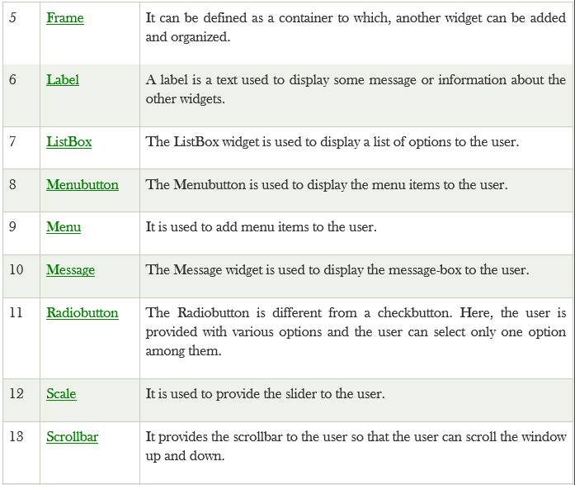



C:\Users\DELL LATITUDE\Pictures\6.2.PNG

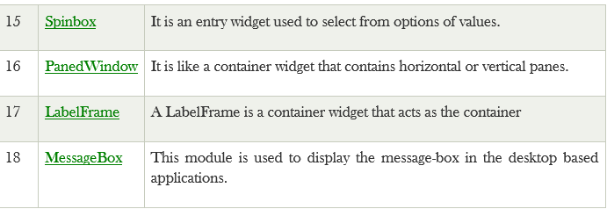

**9. INSTALLATION OF PYTHON**

**Step 1: Download Python 3.9**

To start, go to [python.org/downloads](https://www.python.org/downloads/) and then click on the button to download the latest version of Python:

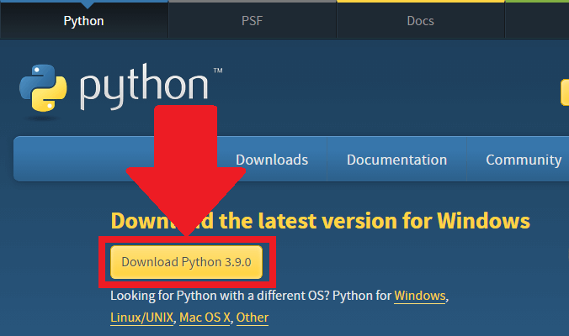

**Step 2: Run the .exe file**

Next, run the .exe file that you just downloaded:

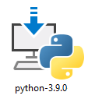

**Step 3: Install Python 3.9**

You can now start the installation of Python by clicking on **Install Now**:

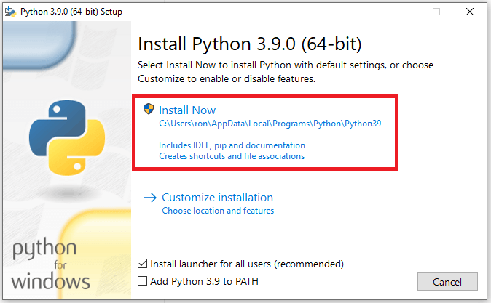

depending on your needs, you may also check the box to add Python to the Path.

Your installation should now begin:

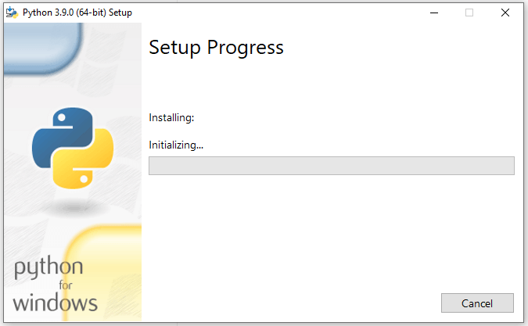

After a short period of time, your setup would be completed:

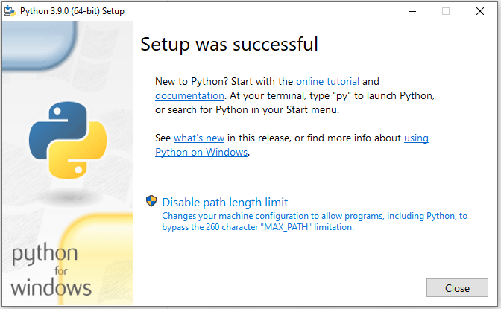

Congrats, you just installed Python on Windows!

**Run a Code in Python**

You can run a code in Python via the Python IDLE.

A quick way to find your Python IDLE on Windows is by clicking on the *Start* menu. You should then see the IDLE under “Recently added”

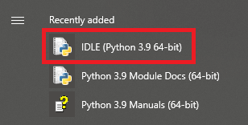

Once you click on the Python IDLE, you’ll see the Shell screen:

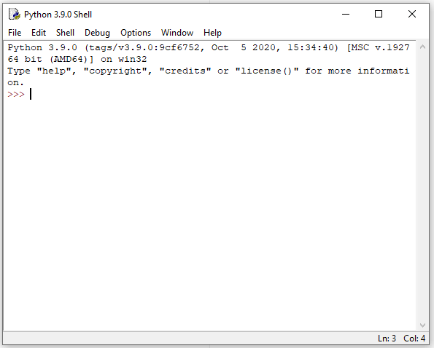

Click on **File** and then select**New File** (alternatively, you may use the keyboard shortcut of Ctrl+N):

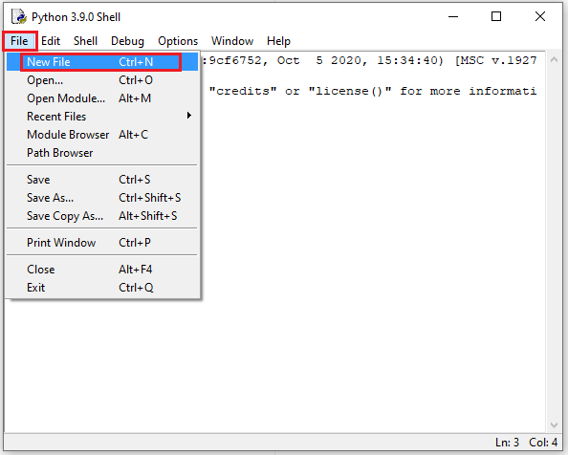

You would now see the following “untitled” box, where you can type your Python code:

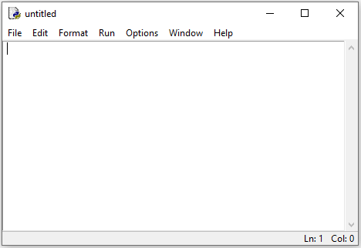

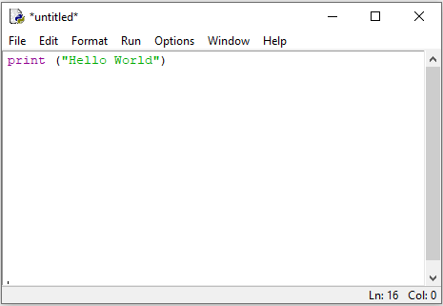

You would now see the following “untitled” box, where you can type your Python code:

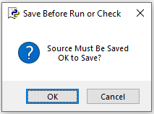

Choose a location where the Python file will be saved on your computer. You’ll also need to type a name for your file. For example, type “Test” for your file name:

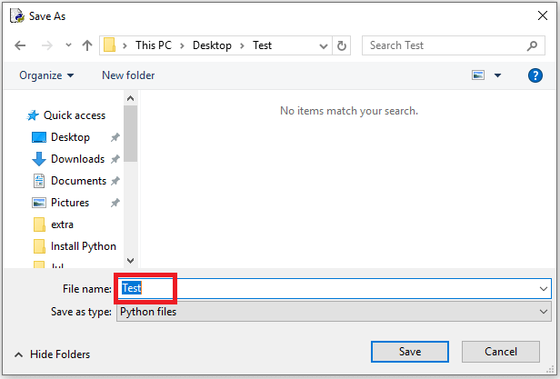

Once you’re done, press **Save,** and you’ll then see the “Hello World” expression printed on your Python Shell:

**10. SYSTEM REQUIREMENTS SPECIFICATIONS**

For this project minimum hardware and software requirement are listed below:

The hardware requirements stated above are recommended for the optimum possible performance of the new system (computerized system).

|  |  |
| --- | --- |
| Hardware Requirements | |
| **Processor** | Dual-core 64-bit processor |
| **RAM** | 4 GB RAM minimum, 8 GB RAM recommended |
| **Hard Disk** | 2 GB of available disk space minimum, 4 GB Recommended (500 MB for IDE + 1.5 GB ) |

|  |  |
| --- | --- |
| Software Requirements | |
| **Front End Tool** | Python 3 |
| **Languages used** | Python 3, MySQL DB |
| **Operating System** | Microsoft Windows7/8/10 (32- or 64-bit) |
| **Screen Resolution** | 1280 x 800 minimum screen resolution |
| **Technologies** | Python |
| **Any Other Software** | PyCharms, IDLE |

**11. PROJECT TECHNICALITIES**

Screenshot of basic coding in front frame and API work

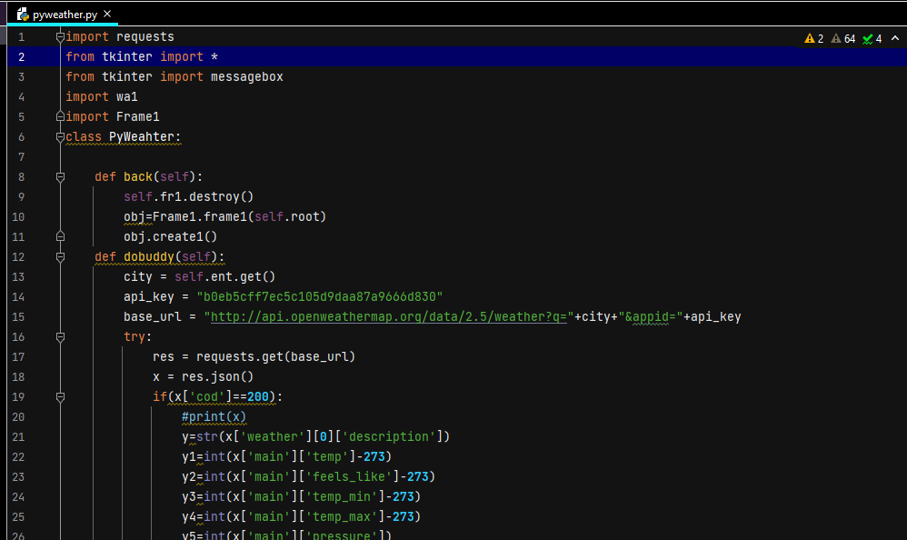

Front frame (Login Page)

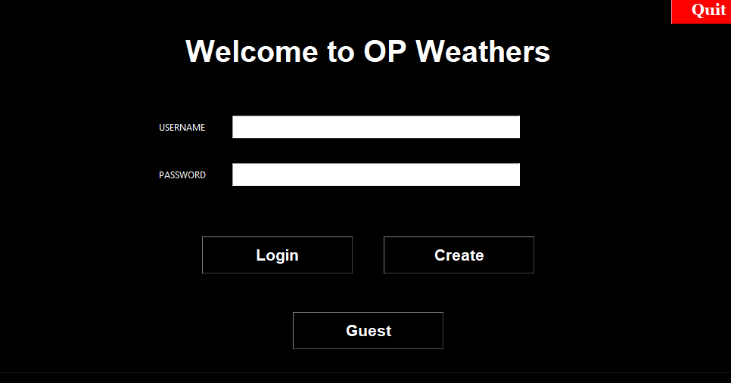

Main weather processing frame

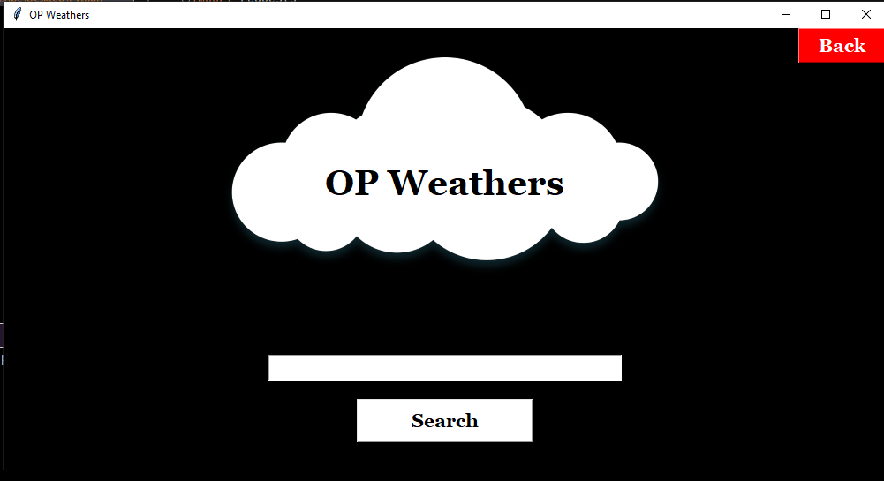

**Fetched weather using its functionality**

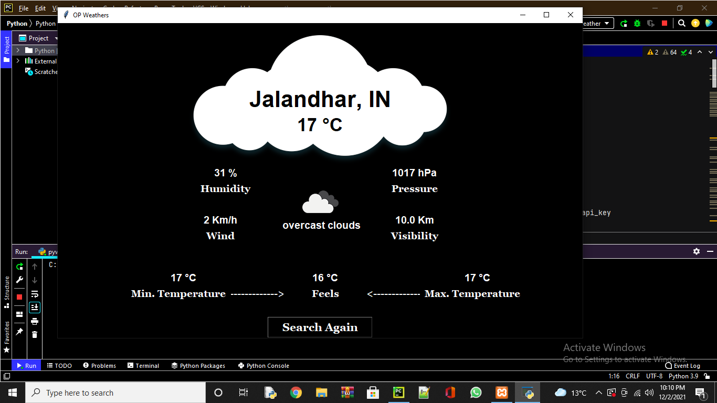

**Create profile page**

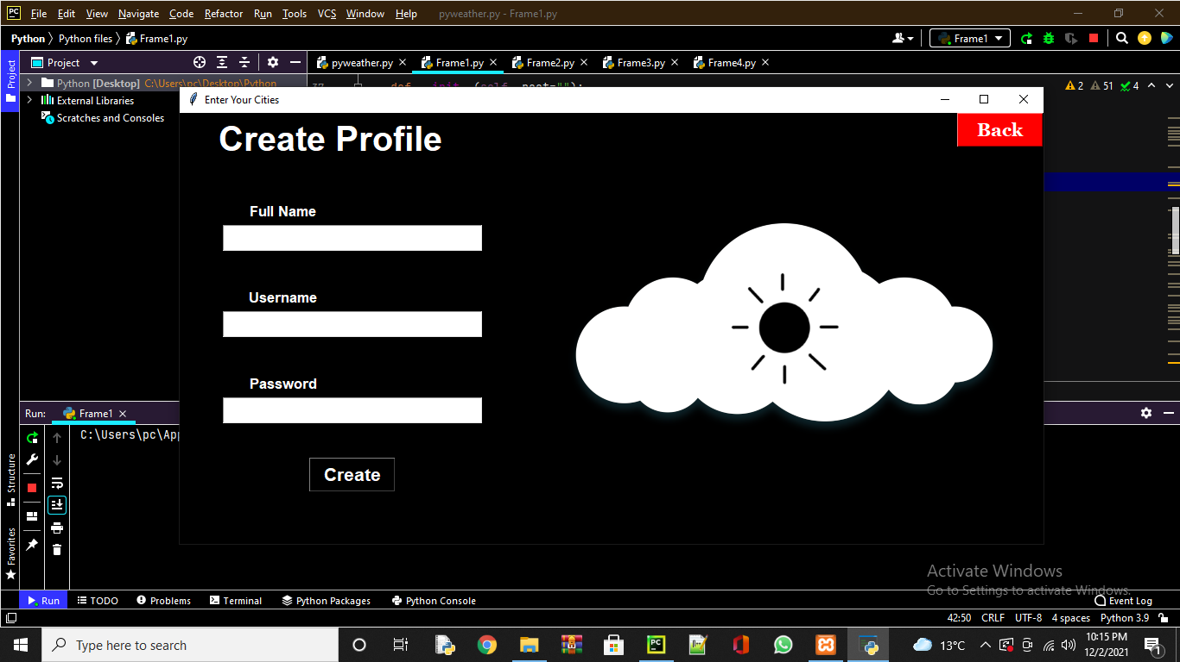

Asks before exit

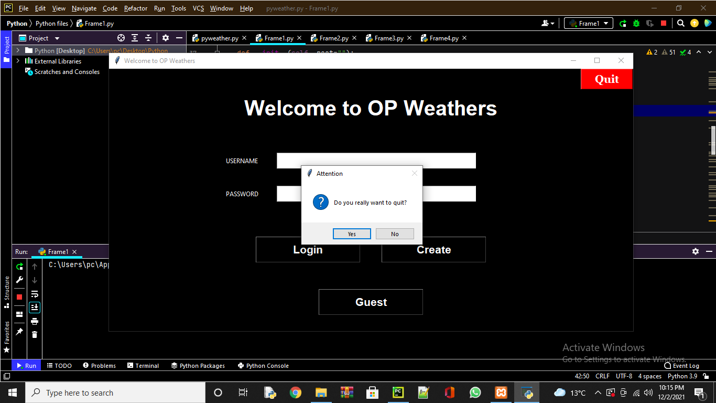

Search again option

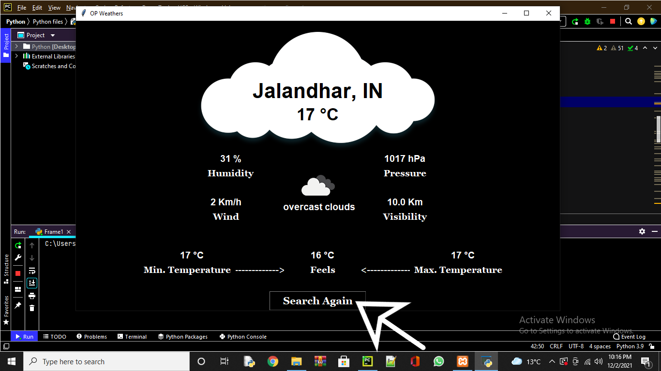

Weather fetch code using API

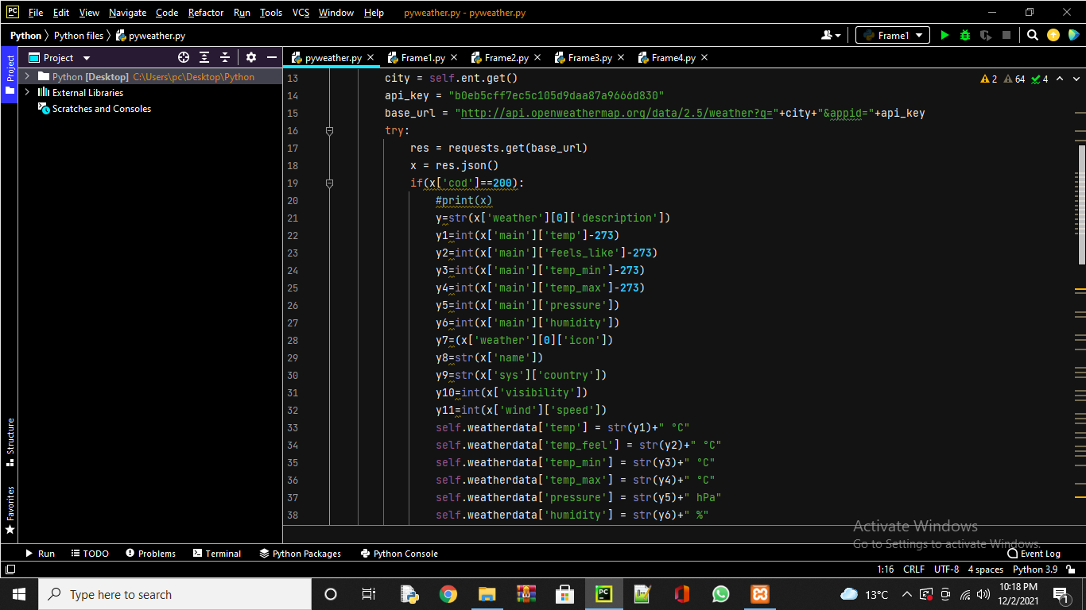

Basic code for creating root window

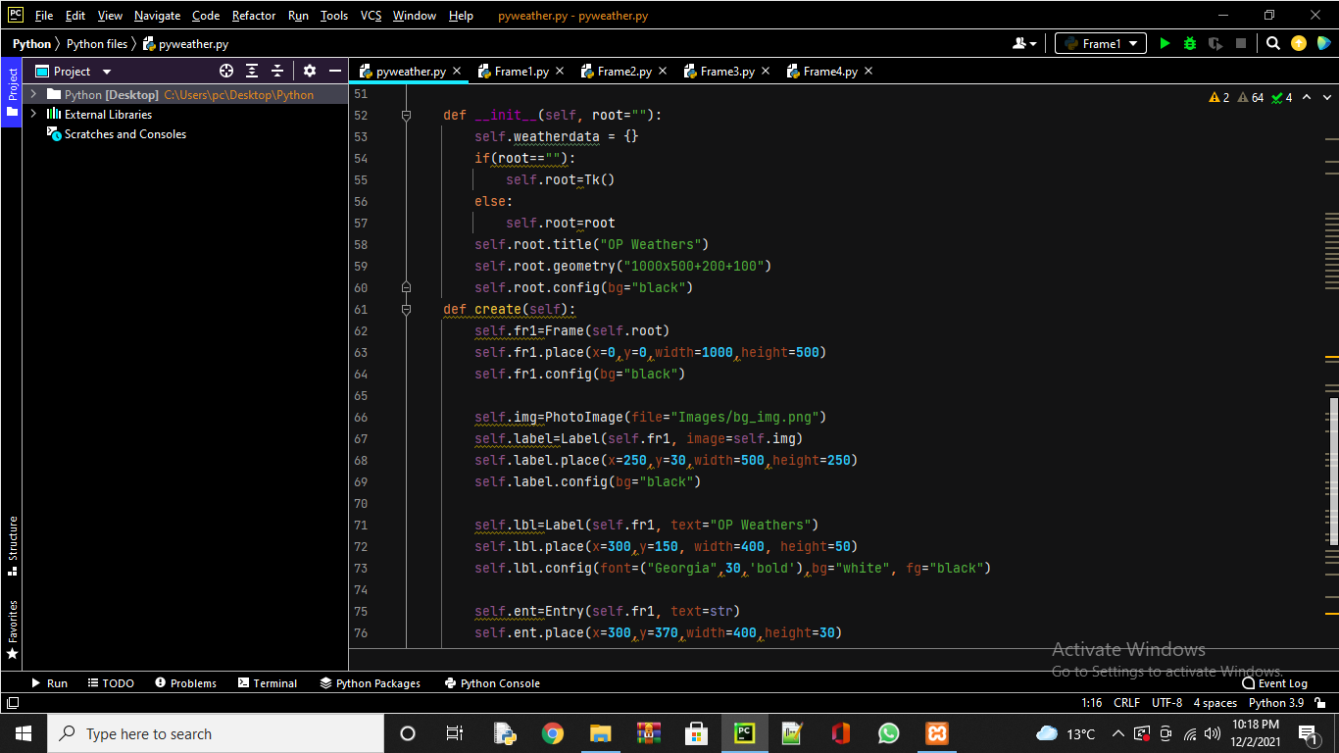

Code for creating visual items in the root window

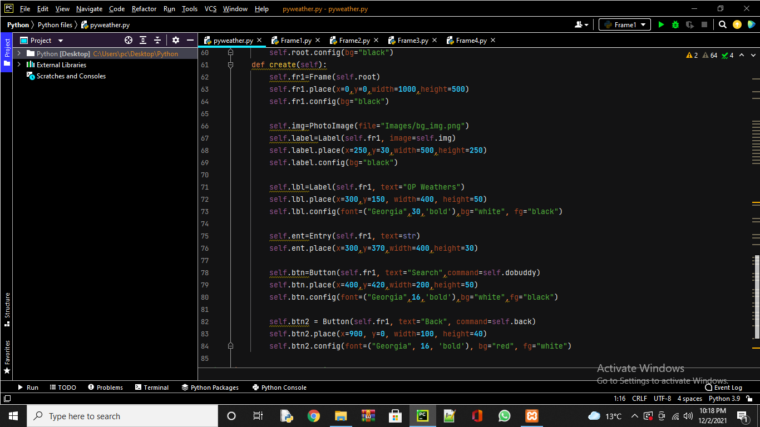

Code for conversion of units inside the frame

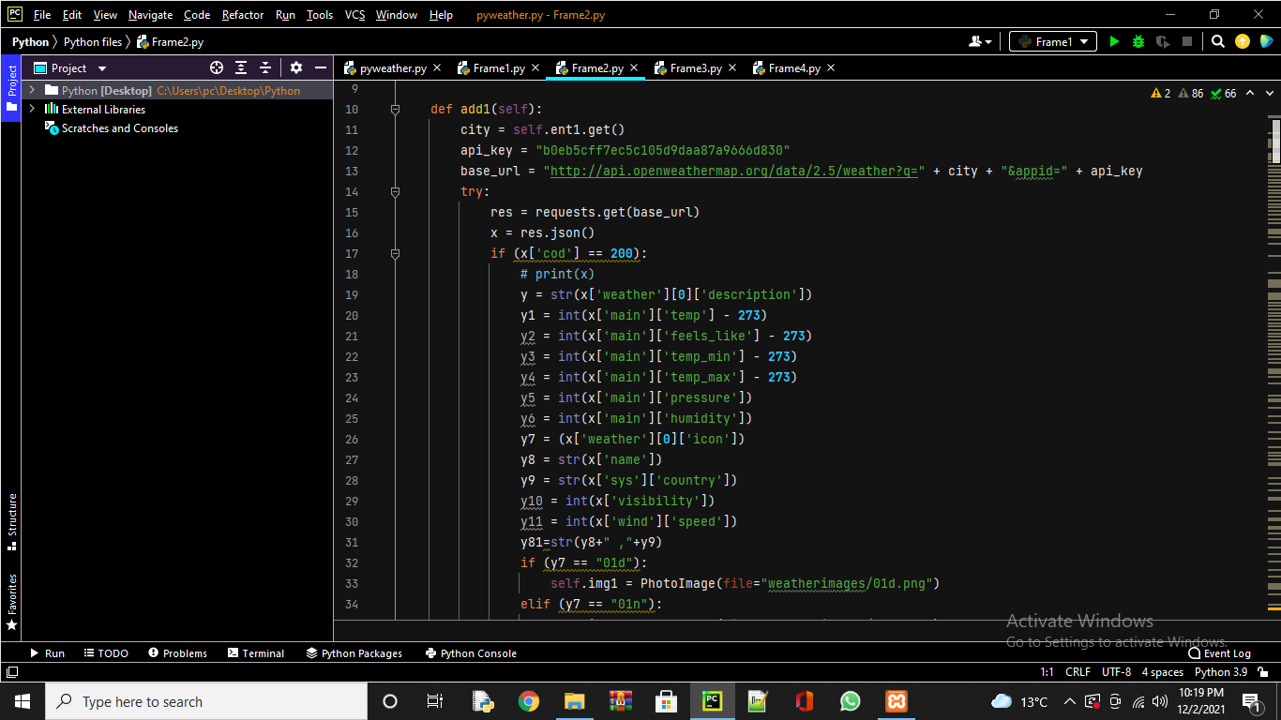

Code for inserting images according to the particular weather

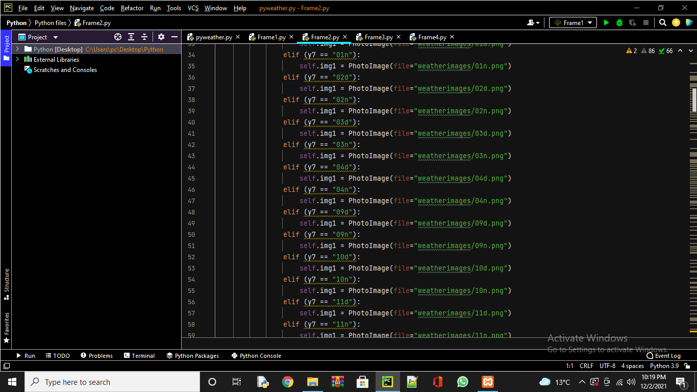

Database file operating using mysql connector

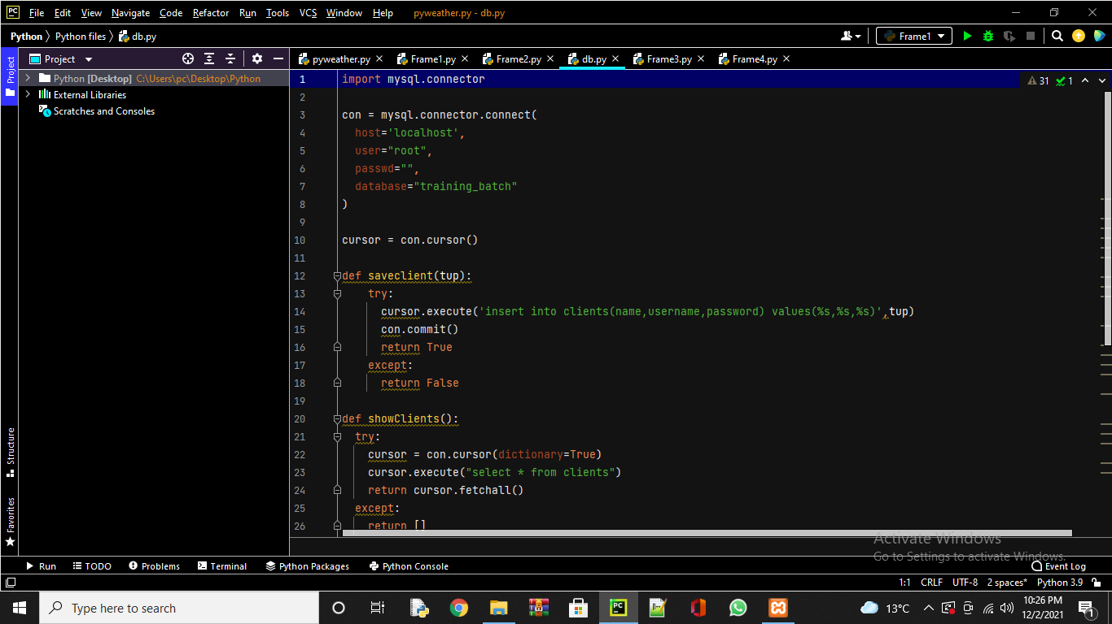

**12. CONCLUSION &FUTURE SCOPE**

**CONCLUSION**

The system has been developed for the given condition and is found working effectively. The developed system is flexible and changes can be made easily whenever required. Using the facilities and functionalities of Python 3, the software has been developed in a neat and simple manner, thereby reducing the operator’s work.

The speed and accuracy are maintained in proper way. The user-friendly nature of this software developed in Python framework is very easy to work with both the higher management as well as other users with little knowledge of computer. The results obtained were fully satisfactory from the user point of view..

The project has been completed successfully with the maximum satisfaction of the organization. The constraints are met and overcome successfully. The system is designed as like it was decided in the design phase. The project gives good idea on developing a full-fledged application satisfying the user requirements

**FUTURE SCOPE**

Completion of development process will result in a software package that will provide user-friendly environment, which is very easy to work with, even for people with very little knowledge of computer.

Management of various tasks is incorporated in the package and will deliver the required information in a very easy to access manner. This package will provide accuracy, efficiency, speed and easiness to the end user. Since the system is verified with valid as well as invalid data and is run with an insight into the necessary modifications that may require in the future, it can be maintained successfully without much